Name:

Debenham High School

Subject Guidance
February 2019

The following booklet gives key information for all the examinations studied by current Year 11 students. You will find links to the examination board specification, key revision guidance and breakdown of assessment structure for each subject. Students will receive further detailed revision resources from their teachers but this should act as an overview and link to further resources for each subject area.

Please do not hesitate to ask if there is any further information that would be helpful to your daughter or son.

English Language - 3 -
English Literature - 6 -
Mathematics - 9 -
Science: Combined Science and Biology, Chemistry, Physics - 13 -
Art - 17 -
Business - 18 -
Computer Science - 20 -
Drama - 21 -
GCSE Design Technology - 22 -
DT Food and Nutrition - 24 -
French - 26 -
Health and Social Care - 28 -
Film Studies - 29 -
Geography - 31 -
History - 33 -
Music - 35 -
PE - 37 -
RE Short Course - 39 -
GCSE RE Full Course - 41 -
Visual Communication: Level 2 Technical Award - 44 -

Subject guidance

English Language
Exam Board
AQA
http://www.aqa.org.uk/subjects/english/gcse/english-language-8700
http://filestore.aqa.org.uk/resources/english/specifications/AQA-8700-SP-2015.PDF
Past Papers or Specimen papers and mark schemes
http://www.aqa.org.uk/subjects/english/gcse/english-language-8700/assessment-resources
How does the overall grade break down?

Paper 1: Explorations in Creative Reading and Writing – 50% - 1 hour 45 minutes
Paper 2: Writers’ viewpoints and perspectives – 50% - 1 hour 45 minutes

Guidance for Revision
- Using a revision guide or topic list (given by your teacher) to cover all the areas in each of the examinations so that you know what you need to cover.
- Making notes on each area to remind you of the skills involved.

Paper 1
Question 1
- List 4 things learnt from text
- Focus on specific section of the text
- Pick distinctly different aspects
Question 2
- Focus on the effects of language used in a specific section
- Pick specific words & phrases
- Language features/ techniques
- Sentence forms
- Use synonyms/ trigger words for the words from the text/ effects
- Explain the effects; why have writer’s used the techniques that they have?
- Make sure that you’ve revised techniques
- Don’t just feature spot
- Focus in on specific words
- No general comments
- Go for more than one effect ‘it could be this/ or that’ ‘not only does this/ but also’
- DON’T DO STRUCTURE
Question 3
- Structure of the whole text
- What do we focus on at the beginning?
- How & why does this change? What to?
- Shift between characters
- Between inside/ outside
- How does it end?
- Think film-like; use of the camera
- Any other features?
- Use of time: chronological, flashbacks, leaps
- DON’T DO LANGUAGE
Question 4
- Critically evaluate a statement based on the text
- Focus on the specific section and discuss likely reactions
- Discuss the extent to which you agree
- Always agree to some extent
- How has the writer achieved the effect? = methods, language as in Q2/ structure as in Q3
- How effectively have they done it? = critical evaluation
Question 5
- Descriptive or narrative writing
- Choice from 2 tasks
- Subtly different techniques for different forms but…
- You will need to be able to use techniques revised for language analysis: sensory details, emotive vocabulary/ adjectives, imagery etc
- Better vocabulary
- Varied sentence forms/ paragraphs to effect
- Clear discourse markers
- Not just simple/ compound/ complex sentences
- 1 word sentence
- 1 sentence paragraph
- A range of punctuation above ./,/?
- Techniques/ tone/ address/ formality relevant to audience & purpose
SPAG = 40%
Know your shortcomings & proofread for them

Paper 2
Question 1
- Choose 4/8 statements that are TRUE
- Go through the process of elimination for each statement
Question 2
- Synthesise the differences* between 2 texts (*could be similarities)
- Say a little about a lot
- Make a statement, use a detail, make an inference use a connective, then include detail and inference on the 2nd text
- Aim for at least 3 distinctly different areas
- Make obviously comparative statements ‘more than/less than’
- Don’t go into any language analysis here
Question 3
- Focus on the effects of language used in a specific section
- Pick specific words & phrases
- Language features/ techniques
- Sentence forms
- Use synonyms/ trigger words for the words from the text/ effects
- Explain the effects; why have writer’s used the techniques that they have?
- Make sure that you’ve revised techniques
- Don’t just feature spot
- Focus in on specific words
- No general comments
- Go for more than one effect ‘it could be this/ or that’ ‘not only does this/ but also’
Question 4
- Compare the points of view given in the 2 sources
- Explore the whole of each text
- Choose the aspects/ facets of the point of view
- Ideas/ viewpoint/P.O.V./ perspective NOT content
- Methods
- Connectives of comparison = similarities and differences
- Make obviously comparative statements ‘more than/less than’
- Same technique/ same effect
- Same technique different effect
- Different technique/ same effect
Question 5
- Your own opinion piece of writing
- Use a range of techniques for effect
- Better vocabulary
- Varied sentence forms/ paragraphs to effect
- Clear discourse markers
- Not just simple/ compound/ complex sentences
- 1 word sentence
- 1 sentence paragraph
- A range of punctuation above ./,/?
- Techniques/ tone/ address/ formality relevant to audience & purpose
- Don’t tell your reader off or be aggressive with them
SPAG = 40%
Know your shortcomings & proofread for them

Support the school will provide
- Examination questions (past paper format)
- Topic list to see what must be covered

Examinations
4 June am Paper 1: Explorations in Creative Reading and Writing – 50% - 1 hour 45 minutes
7 June am Paper 2: Writers’ viewpoints and perspectives – 50% - 1 hour 45 minutes

English Literature
Exam Board
AQA
http://www.aqa.org.uk/subjects/english/gcse/english-literature-8702
http://filestore.aqa.org.uk/resources/english/specifications/AQA-8702-SP-2015.PDF
Past Papers or Specimen papers and mark schemes
http://www.aqa.org.uk/subjects/english/gcse/english-literature-8702/assessment-resources
How does the overall grade break down?

Paper 1: Shakespeare and the 19th-century novel – 40% - 1 hour 45 minutes
Paper 2: Modern texts and poetry – 60% - 2 hour 15 minutes

Guidance for Revision
- Using a revision guide or topic list (given by your teacher) to cover all the areas in each of the examinations so that you know what you need to cover.
- Making notes on each area to remind you of the skills involved.

Paper 1
Students have ALL studied Romeo and Juliet and An Inspector Calls
Students have also studied either Jane Eyre OR Christmas Carol
Romeo and Juliet |  | Jane Eyre
Plot (What happens) |  | Plot (What happens)
Characters |  | Characters
Romeo |  | Jane
Juliet |  | Rochester
Lord Capulet |  | St John
Friar Lawrence |  | Bertha
The Nurse |  | Mr Brocklehurst
Tybalt |  | Miss Temple
Mercutio |  | Aunt Reed and children
Benvolio |  | Helen Burns
Lady Capulet |  | Blanche Ingram
Prince Escalus
Themes |  | Themes
Love |  | Love and marriage
Conflict, honour and feuds |  | Gender roles
Fate and destiny |  | Social status
Family and marriage |  | Religion & morality
Religion |  | Family
 |  | Outsiders
OR
A Christmas Carol
Plot (What happens)
Characters
Scrooge
Marley
Ghost of Christmas Past
Ghost of Christmas Present
Ghost of Christmas Yet to Come
Fred
The Cratchits
Themes
Love and marriage
Gender roles
Social status
Religion & morality
Family
Outsiders

Paper 2
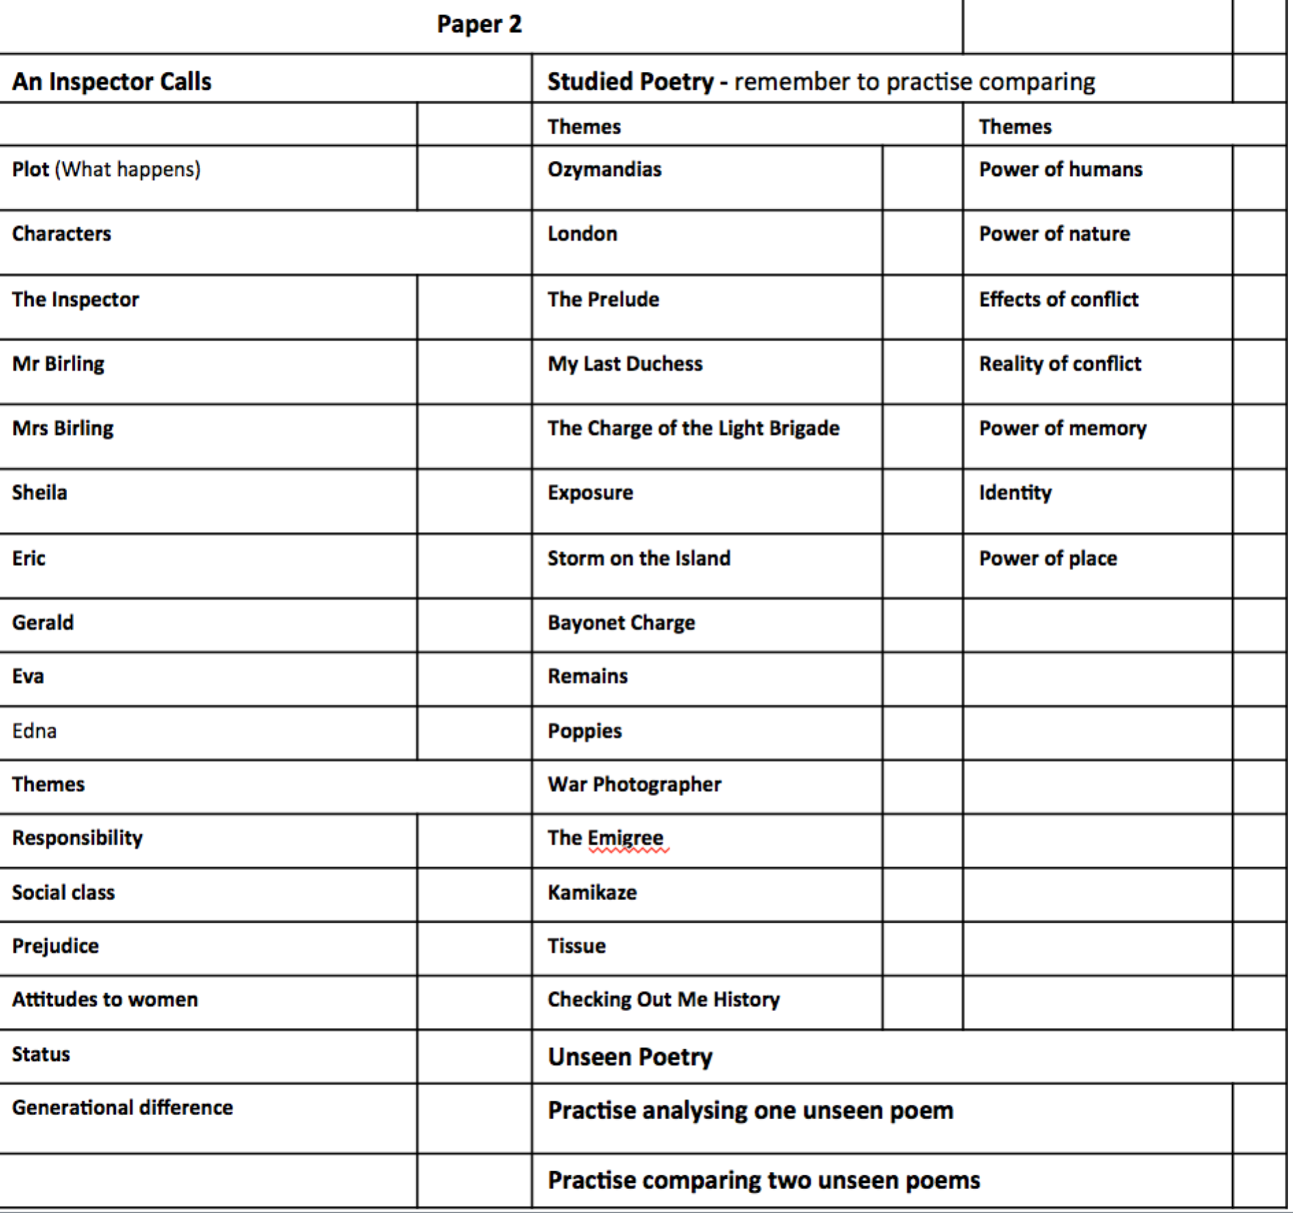
Support the school will provide
- Examination questions (past paper format)
- Topic list to see what must be covered

Examinations
15 May Paper 1: Shakespeare and the 19th-century novel – 40% - 1 hour 45 minutes
23 May Paper 2: Modern texts and poetry – 60% - 2 hour 15 minutes

Mathematics
Exam Board
AQA
http://www.aqa.org.uk/subjects/mathematics/gcse/mathematics-8300
http://filestore.aqa.org.uk/resources/mathematics/specifications/AQA-8300-SP-2015.PDF
Past Papers or Specimen papers and mark schemes
Paper copies can be obtained from Mathematics Department
http://www.aqa.org.uk/subjects/mathematics/gcse/mathematics-8300/assessment-resources
How does the overall grade break down?

Paper 1: Non-calculator – 80 marks - 33.3% - 1 hour 30 minutes
Paper 2: Calculator – 80 marks -33.3% - 1 hour 30 minutes
Paper 3: Calculator –80 marks - 33.3% - 1 hour 30 minutes

Guidance for Revision
- Using the Maths Watch CD and the revision guide to work through each skill
- Using a revision guide or topic list (given by your teacher) to cover all the areas so that you know what you need to cover.
- Making notes on each area to remind you of the skills involved.
- Practising exam questions again and again to make sure you know thoroughly and can use them in different questions.

Foundation Tier
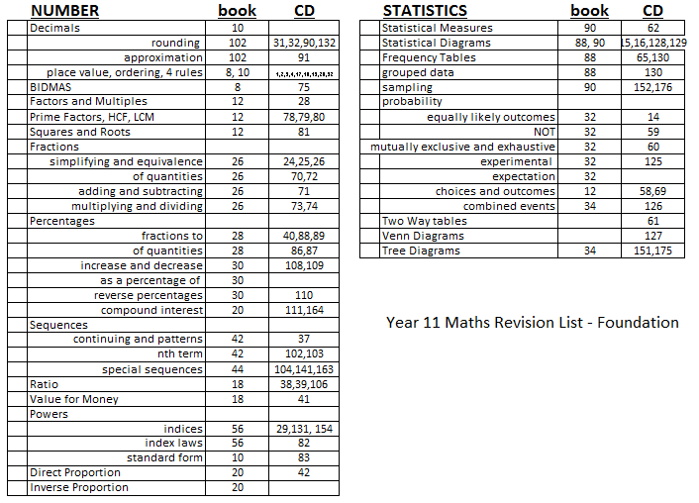
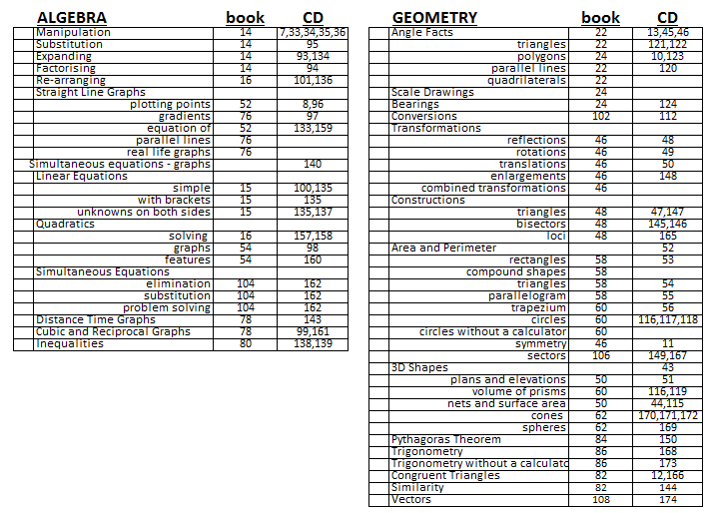

Higher Tier
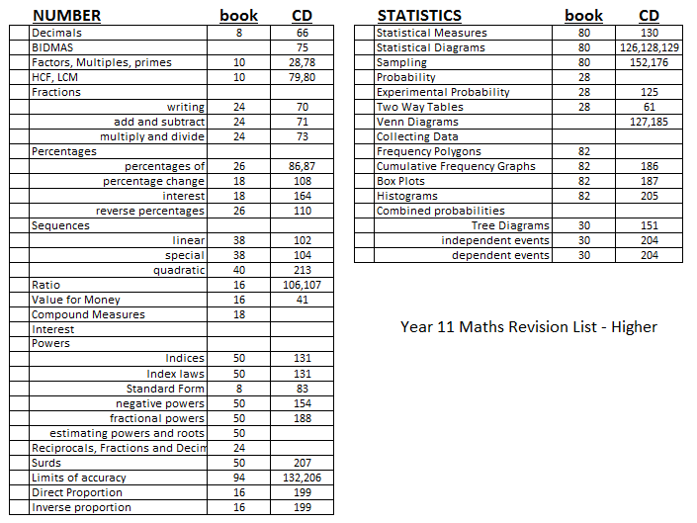
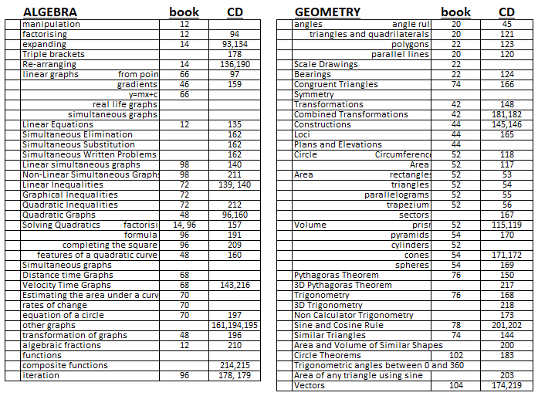

Support the school will provide
- Examination questions (past paper format)
- Topic list to see what must be covered
- Revision sessions (lunchtime and after school)

Exams
21 May am Paper 1: Non-calculator – 33.3% - 1 hour 30 minutes
6 June am Paper 2: Calculator – 33.3% - 1 hour 30 minutes
11 June am Paper 3: Calculator – 33.3% - 1 hour 30 minutes

Science: Combined Science and Biology, Chemistry, Physics
Exam Board
Pearson
https://qualifications.pearson.com/en/qualifications/edexcel-gcses/sciences-2016.coursematerials.html#filterQuery=category:Pearson-UK:Category%2FSpecification-and-sample-assessments
Biology
https://qualifications.pearson.com/content/dam/pdf/GCSE/Science/2016/Specification/Edexcel_GCSE_L1-L2_Biology.pdf
Chemistry
https://qualifications.pearson.com/content/dam/pdf/GCSE/Science/2016/Specification/Edexcel_GCSE_L1-L2_Chemistry.pdf
Physics
https://qualifications.pearson.com/content/dam/pdf/GCSE/Science/2016/Specification/Edexcel_GCSE_L1-L2_Physics.pdf
Combined Science
https://qualifications.pearson.com/content/dam/pdf/GCSE/Science/2016/Specification/GCSE_CombinedScience_Spec.pdf
Past Papers
https://qualifications.pearson.com/en/qualifications/edexcel-gcses/sciences-2016.coursematerials.html#filterQuery=category:Pearson-UK:Category%2FSpecification-and-sample-assessments
How does the overall grade break down?

Biology
Paper 1: Written paper 50% - 1 hour 45 minutes
Paper 2: Written paper 50% - 1 hour 45 minutes

Chemistry
Paper 1: Written paper 50% - 1 hour 45 minutes
Paper 2: Written paper 50% - 1 hour 45 minutes

Physics
Paper 1: Written paper 50% - 1 hour 45 minutes
Paper 2: Written paper 50% - 1 hour 45 minutes

Combined Science
Biology 1: Written paper 16.67% - 1 hour 10 minutes
Biology 2: Written paper 16.67% - 1 hour 10 minutes
Chemistry 1: Written paper 16.67% - 1 hour 10 minutes
Chemistry 2: Written paper 16.67% - 1 hour 10 minutes
Physics 1: Written paper 16.67% - 1 hour 10 minutes
Physics 2: Written paper 16.67% - 1 hour 10 minutes

Guidance for Revision
- Using a revision guide or topic list (given by your teacher) to cover all the areas in each of the examinations so that you know what you need to cover.
- Making notes on each area to remind you of the skills involved.
- Practising exam questions again and again and again to make sure you know the skills inside out and back to front and can use them in different questions.

Biology
Paper 1
- Topic 1 – Key concepts in biology
- Topic 2 – Cells and control
- Topic 3 – Genetics
- Topic 4 – Natural selection and genetic modification
- Topic 5 – Health, disease and the development of medicines
Paper 2
- Topic 1 – Key concepts in biology
- Topic 6 – Plant structures and their functions
- Topic 7 – Animal coordination, control and homeostasis
- Topic 8 – Exchange and transport in animals
- Topic 9 – Ecosystems and material cycles

Chemistry
Paper 1
- Topic 1 – Key concepts in chemistry
- Topic 2 – States of matter and mixtures
- Topic 3 – Chemical changes
- Topic 4 – Extracting metals and equilibria
- Topic 5 – Separate chemistry 1
Paper 2
- Topic 1 – Key concepts in chemistry
- Topic 6 – Groups in the periodic table
- Topic 7 – Rates of reaction and energy changes
- Topic 8 – Fuels and Earth science
- Topic 9 – Separate chemistry 2

Physics
Paper 1
- Topic 1 – Key concepts of physics
- Topic 2 – Motionandforces
- Topic 3 – Conservation of energy
- Topic 4 – Waves
- Topic 5 – Light and the electromagnetic spectrum
- Topic 6 – Radioactivity
- Topic 7 – Astronomy
Paper 2
- Topic 1 – Key concepts of physics
- Topic 8 – Energy - Forces doing work
- Topic 9 – Forces and their effects
- Topic 10 – Electricity and circuits
- Topic 11 – Static electricity
- Topic12 – Magnetism and the motor effect
- Topic13 – Electromagnetic induction
- Topic 14 – Particle model
- Topic 15 – Forces and matter

Combined Science
Biology 1
- Topic 1 – Key concepts in biology, Topic 2 – Cells and control, Topic 3 – Genetics, Topic 4 – Natural selection and genetic modification, Topic 5 – Health, disease and the development of medicines
Biology 2
- Topic 1 – Key concepts in biology, Topic 6 – Plant structures and their functions, Topic 7 – Animal coordination, control and homeostasis, Topic 8 – Exchange and transport in animals, Topic 9 – Ecosystems and material cycles
Chemistry 1
- Topic 1 – Key concepts in chemistry, Topic 2 – States of matter and mixtures, Topic 3 – Chemical changes, Topic 4 – Extracting metals and equilibria
Chemistry 2
- Topic 1 – Key concepts in chemistry, Topic 6 – Groups in the periodic table, Topic 7 – Rates of reaction and energy changes, Topic 8 – Fuels and Earth science
Physics 1
- Topic 1 – Key concepts of physics, Topic 2 – Motion and forces, Topic 3 – Conservation of energy, Topic 4 – Waves, Topic 5 – Light and the electromagnetic spectrum, Topic 6 – Radioactivity
Physics 2
- Topic 1 – Key concepts of physics, Topic 8 – Energy - Forces doing work, Topic 9 – Forces and their effects, Topic 10 – Electricity and circuits, Topic 12 – Magnetism and the motor effect, Topic 13 – Electromagnetic induction, Topic 14 – Particle model, Topic 15 – Forces and matter

Support the school will provide
- Examination questions (past paper format)
- Topic list to see what must be covered
- Activelearn online questions are available at all times

Exams
Biology
15 May pm Paper 1: Written paper 50% - 1 hour 45 minutes
7 June pm Paper 2: Written paper 50% - 1 hour 45 minutes

Chemistry
16 May am Paper 1: Written paper 50% - 1 hour 45 minutes
12 June am Paper 2: Written paper 50% - 1 hour 45 minutes

Physics
22 May pm Paper 1: Written paper 50% - 1 hour 45 minutes
14 June am Paper 2: Written paper 50% - 1 hour 45 minutes

Combined Science
15 May pm Biology 1: Written paper 16.67% - 1 hour 10 minutes
7 June pm Biology 2: Written paper 16.67% - 1 hour 10 minutes
16 May am Chemistry 1: Written paper 16.67% - 1 hour 10 minutes
12 June am Chemistry 2: Written paper 16.67% - 1 hour 10 minutes
22 May pm Physics 1: Written paper 16.67% - 1 hour 10 minutes
14 June am Physics 2: Written paper 16.67% - 1 hour 10 minutes

Art
Exam Board
AQA
http://www.aqa.org.uk/subjects/art-and-design/gcse/art-and-design-8201-8206
http://filestore.aqa.org.uk/resources/art-and-design/specifications/AQA-ART-GCSE-SP-2016.PDF
Past Papers or Specimen papers and mark schemes
http://www.aqa.org.uk/subjects/art-and-design/gcse/art-and-design-8201-8206/assessment-resources
How does the overall grade break down?
Component 1 – portfolio – 60%
Component 2 – exam – 40%
Guidance for Revision
Year 11 exam preparation runs from January 1st to April 22nd. Please complete exam preparation sketchbook instead of weekly revision.
This must be given the same amount of time as subject revision out of school.
Tasks for class and homework will be set each week. Each task must be completed to a good standard to pass the exam at your expected level. Please factor these tasks into revision timetables.
1 | Mind map
2 | Photo shoot 1
3 | A3 gridded drawing
4 | A3 gridded drawing
5 | Research article / newspaper & visual response
6 | Artist study
7 | Artist react long written version (see help sheet)
8 | Manipulated photos (practical or photoshop)
9 | Mini final piece drawing
10 | Final photoshoot
11 | Prep for exam piece

Support the school will provide
There will be lunch and after school sessions available in room 7 throughout the exam prep period.
Exams
Final exam – 23rd & 24th April OR 25th & 26th April

Business
Exam Board
Edexcel
https://qualifications.pearson.com/en/qualifications/edexcel-gcses/business-2017.html
Past Papers or Specimen papers and mark schemes
https://qualifications.pearson.com/en/qualifications/edexcel-gcses/business-2017.coursematerials.html#filterQuery=Pearson-UK:Category%2FTeaching-and-learning-materials
There are only two specimen papers available here. A few more are available as hard copies from Mrs Wilson. Past multiple choice papers are also available from Mrs Wilson to help with subject knowledge.
How does the overall grade break down?
Theme 1: Investigating small businesses (1BS0/01) 50% of qualification, 90 marks written examination

Theme 2: Building a business (1BSO/02) 50% of qualification, 90 marks, written examination
Both papers are divided into three sections:

Section A: 35 marks
Section B: 30 marks
Section C: 25 marks

The papers will consist of calculations, multiple-choice, short-answer and extended-writing questions.

Questions in Sections B and C will be based on business contexts given in the paper.

Guidance for Revision
- Exercise book – the best place
- Using a revision guide or topic booklet to cover all the areas in each of the examinations so that you know what you need to cover.
- Practising exam questions.
- Revision materials already prepared by students for all the course
- Remember to use the technique booklet Exam Excellence
- Use your course companion folder, which includes ‘notes’ of the whole course.
- Revision PowerPoints covering ALL of the course are available on the student shared.
Theme 2: Building a business

2.1 Growing the business
2.2 Making marketing decisions
2.3 Making operational decisions
2.4 Making financial decisions
2.5 Making human resource decisions

Theme 1 Investigating small business

1.1 Enterprise and entrepreneurship
1.2 Spotting a business opportunity
1.3 Putting a business idea into practice
1.4 Making the business effective
1.5 Understanding external influences on business

A more detailed breakdown of these units will be provided to students.

Support the school will provide
- Weekly revision sessions – Tuesday 4pm – 5pm room 11
- Lunchtimes on Monday or Thursday for individual support
- EASTER revision sessions – 9th and 12th April 2019 9.30am – 1.30pm
- MAY HALF TERM 30th May 9.30am – 1.30pm

Exams
Friday 24th May am Investigating small businesses – 50%, 1hr 30 min written examination
Tuesday 4th June pm Building a business – 50% - 1 hour 30 mins examination

Computer Science
Exam Board
OCR
http://www.ocr.org.uk/Images/225975-specification-accredited-gcse-computer-science-j276.pdf
Past Papers or Specimen papers and mark schemes
http://www.ocr.org.uk/qualifications/gcse-computer-science-j276-from-2016/assessment/
How does the overall grade break down?
Computer systems – 50% - 1 hour 30 minute examination
Computational Thinking, Algorithms and Programming – 50% - 1 hour 30 mins examination

Guidance for Revision
- Using a revision guide or topic list (given by your teacher) to cover all the areas in each of the examinations so that you know what you need to cover.
- Making notes on each area to remind you of the skills involved.
- Practising exam questions again and again and again to make sure you know the skills inside out and back to front and can use them in different questions.

Computer systems
- Systems architecture
- Computer memory and storage
- Network topologies, protocols and layers
- System security
- System software
- Ethical, legal, cultural and environmental concerns
Computational thinking, algorithms and programming
- Algorithms
- Programming techniques
- Producing robust programs
- Translators and facilities of languages
- Data representation
Support the school will provide
- Examination questions (past paper format)
- Topic list to see what must be covered
- Revision sessions – Tuesday lunchtime and Wednesday after school

Exams
13 May am Computer systems – 50% - 1 hour 30 minute examination
16 May pm Computational Thinking, Algorithms and Programming – 50% - 1 hour 30 mins examination

Drama
Exam Board
Pearson
http://qualifications.pearson.com/en/qualifications/edexcel-gcses/drama-2016.html
http://qualifications.pearson.com/content/dam/pdf/GCSE/Drama/2016/Specification%20and%20sample%20assessments/gcse_drama_spec_L1_L2.pdf
Past Papers or Specimen papers and mark schemes
http://qualifications.pearson.com/en/qualifications/edexcel-gcses/drama-2016.coursematerials.html#filterQuery=category:Pearson-UK:Category%2FSpecification-and-sample-assessments
How does the overall grade break down?
Devising – 40% - Controlled assessment and externally moderated
Performance – 20% - Externally assessed by visiting examiner
Theatre makers in practice – 40% - 1 hour 30 minute examination

Guidance for Revision
- Using a revision guide or topic list (given by your teacher) to cover all the areas in each of the examinations so that you know what you need to cover.
- Making notes on each area to remind you of the skills involved.
- Practising exam questions again and again and again to make sure you know the skills inside out and back to front and can use them in different questions.
Bringing texts to life
- Read ‘DNA’ again (copies from Mr Hardcastle)
- Student Shared – Drama – GCSE – Component 3 – some very useful guides to the play to read
- Also – PowerPoint gives you tips for mock exam and key vocab you must use in exam
- Collect DNA Revision pack and work through all activities
Live theatre evaluation
- A Complete 500 words of notes on ‘The Kite Runner’
- Collect Section B Revision pack and work through examples
Support the school will provide
- Examination questions (past paper format)
- Topic list to see what must be covered

Exams
Date TBC (April) Performance – 20% - Externally assessed by visiting examiner
17 May pm Theatre makers in practice – 40% - 1 hour 30 minute examination

GCSE Design Technology
Exam Board
AQA
https://www.aqa.org.uk/subjects/design-and-technology/gcse/design-and-technology-8552

Past Papers or Specimen papers and mark schemes
There are two specimen papers available which Miss Newman will give you before the Easter holidays.
How does the overall grade break down?
- Exam – 2 hours long. Some multiple choice questions, some short answer questions, and some extended response questions. (50% of GCSE)
- NEA – your design and make project that you have nearly finished (50% of GCSE).
Guidance for Revision
- Use revision cards to help you revise and subject revision book if you purchased one.
- Use A3 topic list (in your A3 theory booklets) to make sure you know what you have to learn.
- Make notes on each area to remind you of the skills involved.
- Practise exam questions again and again
- Use your materials cards to help you learn them all.

Subject Areas Covered in Exam
- New and emerging technologies.
- Energy generation and storage.
- Development in new materials
- Systems approach to designing
- Mechanical devices
- Materials and their working properties.
- Material properties
- Forces and stresses
- Ecological and social footprint
- Sources and origins of polymers and timber based materials
- Modification of properties in polymers for specific purposes
- How to shape and form working in wood and plastic.
- Stock forms, types and sizes.
- How to use measurement/reference points, templates, jigs, and patterns.
- Tools, equipment and processes.
- How materials are cut, shaped and formed to a tolerance.
- Commercial processes in polymers.
- Quality control.
- Surface treatments and finishes.
- Design process.
- The work of other designers – Alessi, Foster, Dyson, Philippe Starck.
- Design strategies.
- Drawing techniques.
- Materials management.

Support the school will provide
- Two specimen papers.
- Remaining revision cards.
- Catch-up sessions until Easter to get Non-Examined Assessment complete.

Exams
23 May pm Design and Technology 50% 2 hour examination

DT Food and Nutrition
Exam Board
OCR
http://www.ocr.org.uk/qualifications/gcse-food-preparation-and-nutrition-j309-from-2016/
http://www.ocr.org.uk/Images/234806-specification-accredited-gcse-food-preparation-and-nutrition-j309.pdf
Past Papers or Specimen papers and mark schemes
http://www.ocr.org.uk/qualifications/gcse-food-preparation-and-nutrition-j309-from-2016/assessment/
How does the overall grade break down?
Food preparation and nutrition– 50% - 1 hour 30 minute examination
NEA Task 1-Food investigation task – 15% - Non examined task.
NEA Task 2-Food preparation task – 35% - Non examined task (practical assessment).

Guidance for Revision
- Using a revision guide or topic list (given by your teacher) to cover all the areas in each of the examinations so that you know what you need to cover.
- Making notes on each area to remind you of the skills involved.
- Practising exam questions again and again and again to make sure you know the skills inside out and back to front and can use them in different questions.

Section A: Nutrition
- The relationship between diet and health
- Nutritional and dietary needs of different groups of people
- Nutritional needs when selecting recipes for different groups of people
- Energy balance
- Protein
- Fat
- Carbohydrate
- Vitamins
- Minerals
- Water
- Nutritional content of the main commodity groups
Section B: Food (food provenance and food choice)
- Food provenance: source and supply
- Food processing and production
- Food security
- Technological developments to support better health and food production
- Development of culinary traditions (students study British cuisine and a minimum of two international cuisines)
- Factors influencing food choice
Section C: Cooking and food preparation
- Food science
- Sensory properties
- Food safety
Section D: Skills requirements (preparation and cooking techniques)
- Knife skills
- Preparation and techniques
- Cooking methods
- Sauces
- Set a mixture
- Raising agents
- Dough
- Judge and manipulate sensory properties

Support the school will provide
- Examination questions (past paper format)
- Topic list to see what must be covered

Exams
September - Non –Examined Assessment (NEA) Task 1 Food Investigation Task– 15% - Fats and Oils.
Thursday 28th February- Group 1-The Non- Examined Assessment (NEA) Task 2- 35% Food Preparation Task – Three hour practical examination.
Thursday 7th March- Group 2- The Non- Examined Assessment (NEA) Task 2- 35% Food Preparation Task – Three hour practical examination.
10th June a.m. - The Food Preparation and Nutrition Written examination -– 50% - 1 hour 30 minute examination.

French
Exam Board
AQA
http://www.aqa.org.uk/subjects/languages/gcse/french-8658
http://filestore.aqa.org.uk/resources/french/specifications/AQA-8658-SP-2016.PDF
Past Papers or Specimen papers and mark schemes
http://www.aqa.org.uk/subjects/languages/gcse/french-8658/assessment-resources
How does the overall grade break down?
- Listening – 25% - Written exam: 35 minutes (Foundation Tier), 45 minutes (Higher Tier)
- Speaking – 25% - 7–9 minutes (Foundation Tier) + preparation time, 10–12 minutes (Higher Tier) + preparation time
- Writing – 25% - Written exam: 1 hour (Foundation Tier), 1 hour 15 minutes (Higher Tier)
- Reading – 25% - Written exam: 45 minutes (Foundation Tier), 1 hour (Higher Tier)

Guidance for Revision
- Using a revision guide or topic list (given by your teacher) to cover all the areas in each of the examinations so that you know what you need to cover.
- Using all the toolkits provided by you teachers
- Making notes on each area to remind you of the skills involved.
- Practising exam questions again and again and again to make sure you know the skills inside out and back to front and can use them in different questions.

Topic themes
Theme 1: Identity and culture
- Me, my family and friends: Relationships with family and friends; Marriage/partnership
- Technology in everyday life: Social media; Mobile technology
- Free-time activities: Music; Cinema and TV; Food and eating out; Sport
Theme 2: Local, national, international and global areas of interest
- Home, town, neighbourhood and region
- Social issues: Charity/voluntary work; Healthy/unhealthy living
- Global issues: The environment; Poverty/homelessness
- Travel and tourism
Theme 3: Current and future study and employment
- Topic 1: My studies
- Topic 2: Life at school/college
- Topic 3: Education post-16
- Topic 4: Jobs, career choices and ambitions

Support the school will provide
- Examination questions (past paper format)
- Topic list to see what must be covered and weekly revision plan
- General Conversation Toolkit
- Role-Play Toolkit
- Photo card Toolkit
- Literary texts toolkits (Foundation and Higher)
- Translation toolkits (Foundation and Higher)
- Writing Toolkits (Foundation and Higher)
- Grammar Toolkits
- Wednesday Lunchtime (Speaking) and Monday after school revision sessions (Listening/Literary texts/Translation skills)
- Easter Holiday Revision Morning Thursday 11th April from 9.30 am to 12.30.

Exams
- Week of 29th April (individual appointments to be confirmed) Speaking – 25% - 7–9 minutes (Foundation Tier) + preparation time, 10–12 minutes (Higher Tier) + preparation time
- 14th May am Listening – 25% - Written exam: 35 minutes (Foundation Tier), 45 minutes (Higher Tier)
- 14th May am Reading – 25% - Written exam: 45 minutes (Foundation Tier), 1 hour (Higher Tier)
- 17th May am Writing – 25% - Written exam: 1 hour (Foundation Tier), 1 hour 15 minutes (Higher Tier)

Health and Social Care
Exam Board
Pearson
https://qualifications.pearson.com/en/qualifications/btec-tech-awards/health-and-social-care.html
Past Papers or Specimen papers and mark schemes
https://qualifications.pearson.com/en/qualifications/btec-tech-awards/health-and-social-care.coursematerials.html#filterQuery=Pearson-UK:Category%2FSpecification-and-sample-assessments
How does the overall grade break down?

Component 1 – Lifespan and Development – 2 internal assessments – 30%
Component 2 – Health and Social Care Services and Values - 2 internal assessments – 30%
Component 3 – Health and Wellbeing – external 2 hour exam – 40%

Guidance for Revision
- Using a revision guide (given by your teacher)
- Using past papers

Component 3 Paper

- Question 1 and 2 – Review Case Study
- Question 3 – Interpreting data (eg Lifestyle, Blood Pressure, BMI, Peak Flow)
- Question 4 – Design a health and wellbeing improvement plan
- Question 5 – Explain your plan
- Question 6 – Discuss obstacles

Support the school will provide
- Examination questions (past paper format)
- Revision Guide

Examinations
1 Feb am Component 3: Health and Wellbeing – 40% - 2 hours
Re-sit opportunity: 15 May am Component 3: Health and Wellbeing – 40% - 2 hours

Film Studies
Exam Board
WJEC/ EDUQAS
https://www.eduqas.co.uk/qualifications/film-studies/gcse/
https://www.eduqas.co.uk/qualifications/film-studies/gcse/eduqas-gcse-film-studies-spec-from-2017-e.pdf
Past Papers or Specimen papers and mark schemes
https://www.eduqas.co.uk/qualifications/film-studies/gcse/WJEC-Eduqas-GCSE-Film-Studies-SAMs.pdf
How does the overall grade break down?
Component 1: Development of US Film – 35% 1 Hour 30 minutes Examination
Component 2: Global Film: Narrative, Representation & Style – 35% 1 hour 30 minutes Examination
Component 3: Opening of a Horror Film – 30% - Non-examined assessment

Guidance for Revision
- Using a revision guide or topic list (given by your teacher) to cover all the areas in each of the examinations so that you know what you need to cover.
- Making notes on each area to remind you of the skills involved.
- Practising exam questions again and again and again to make sure you know the skills inside out and back to front and can use them in different questions.

Make detailed notes on 3 key sequences (beginning, end and one other) from each of the 6 films, combining specific details and the use of techniques to give effects relating to the following areas:

- G – genre. What are the conventions in the film?

- E – events. What is the narrative of the film? How is the story told? How do the theories of Propp, Todorov, Levi-Strauss & Vogler relate to this?

- T – themes. What are the themes that run along underneath events and interactions?

- C – context how do the social, political, historical, technological, cultural, or institutional backgrounds affect the film?

- A – aesthetics. The look of the film’s cinematography and mise-en-scene

- R- representational issues. What real world stereotypes are enforced or broken in how the film shows people? Is this positive, negative or mixed?

Students also need to revise the following by reflecting on examples, activities and mark schemes as well as rehearsing opportunities to write about them:

- Terminology for techniques from the film form (or film language)
- How to write analytically
- Details from the timeline of developments in technological film production for Component 1 Question 3
- Details from the critical literature (Popcorn Muncher article on Masculinity) for Component 1 Question 4
- How to write an analytical comparison for Component 1 Question 5

Support the school will provide
- Examination questions (past paper format)
- Topic list to see what must be covered
- Guidance notes & activities in Student Shared Area including screen shot of stills from key sequences
- Key exam board guidance on which of the areas in the box above need to be covered for each question

Exams
4 June pm Component 3: Moving image – 40% - 1 hour and 45 minute examination

Geography
Exam Board
AQA
http://www.aqa.org.uk/subjects/geography/gcse/geography-8035
http://www.aqa.org.uk/subjects/geography/gcse/geography-8035/introduction
Past Papers or Specimen papers and mark schemes
http://www.aqa.org.uk/subjects/geography/gcse/geography-8035/assessment-resources
How does the overall grade break down?
Unit 1: Living with the physical environment – 35% - Written exam: 1 hour 30 minutes
Unit 2: Challenges in the human environment - 35% - Written exam: 1 hour 30 minutes
Unit 3: Geographical applications and skills 30% - Written exam: 1 hour 15 minutes

Guidance for Revision
- Using a revision guide or topic list (given by your teacher) to cover all the areas in each of the examinations so that you know what you need to cover.
- Making notes on each area to remind you of the skills involved.
- Practising exam questions again and again and again to make sure you know the skills inside out and back to front and can use them in different questions.
Unit 1: Living with the physical environment
- Section A: The challenge of natural hazards
- Section B: The living world
- Section C: Physical landscapes in the UK

Unit 2: Challenges in the human environment
- Section A: Urban issues and challenges
- Section B: The changing economic world
- Section C: The challenge of resource management
Unit 3: Geographical applications and skills
- Section A: Issue evaluation
- Section B: Fieldwork
- Geographical skills

Support the school will provide
- Examination questions (past paper format)
- Topic list to see what must be covered
- Lunchtime revision sessions
Exams
21 May pm Unit 1: Living with the physical environment – 35% - Written exam: 1 hour 30 minutes
5 June pm Unit 2: Challenges in the human environment - 35% - Written exam: 1 hour 30 minutes
13 June am Unit 3: Geographical applications and skills 30% - Written exam: 1 hour 15 minutes

History
Exam Board
Pearson
https://qualifications.pearson.com/en/qualifications/edexcel-gcses/history-2016.html
https://qualifications.pearson.com/content/dam/pdf/GCSE/History/2016/specification-and-sample-assessments/9781446925867_GCSE2016_L12_History_Web.pdf
Past Papers or Specimen papers and mark schemes
https://qualifications.pearson.com/en/qualifications/edexcel-gcses/history-2016.coursematerials.html#filterQuery=category:Pearson-UK:Category%2FSpecification-and-sample-assessments
How does the overall grade break down?
Paper 1: Thematic study and historic environment – 30% - 1 hour and 15 minutes
Paper 2: Period study and British depth study (Cold War/ Elizabeth) – 40% - 1 hour and 45 minutes
Paper 3: Modern depth study (Germany) – 30% - 1 hour and 20 minutes

Guidance for Revision
- Using a revision guide or topic list (given by your teacher) to cover all the areas in each of the examinations so that you know what you need to cover.
- Making notes on each area to remind you of the skills involved.

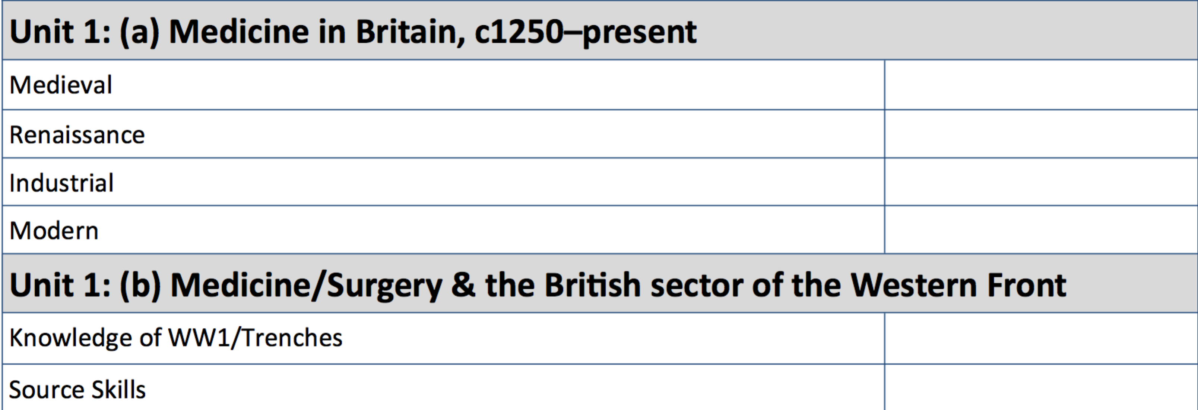

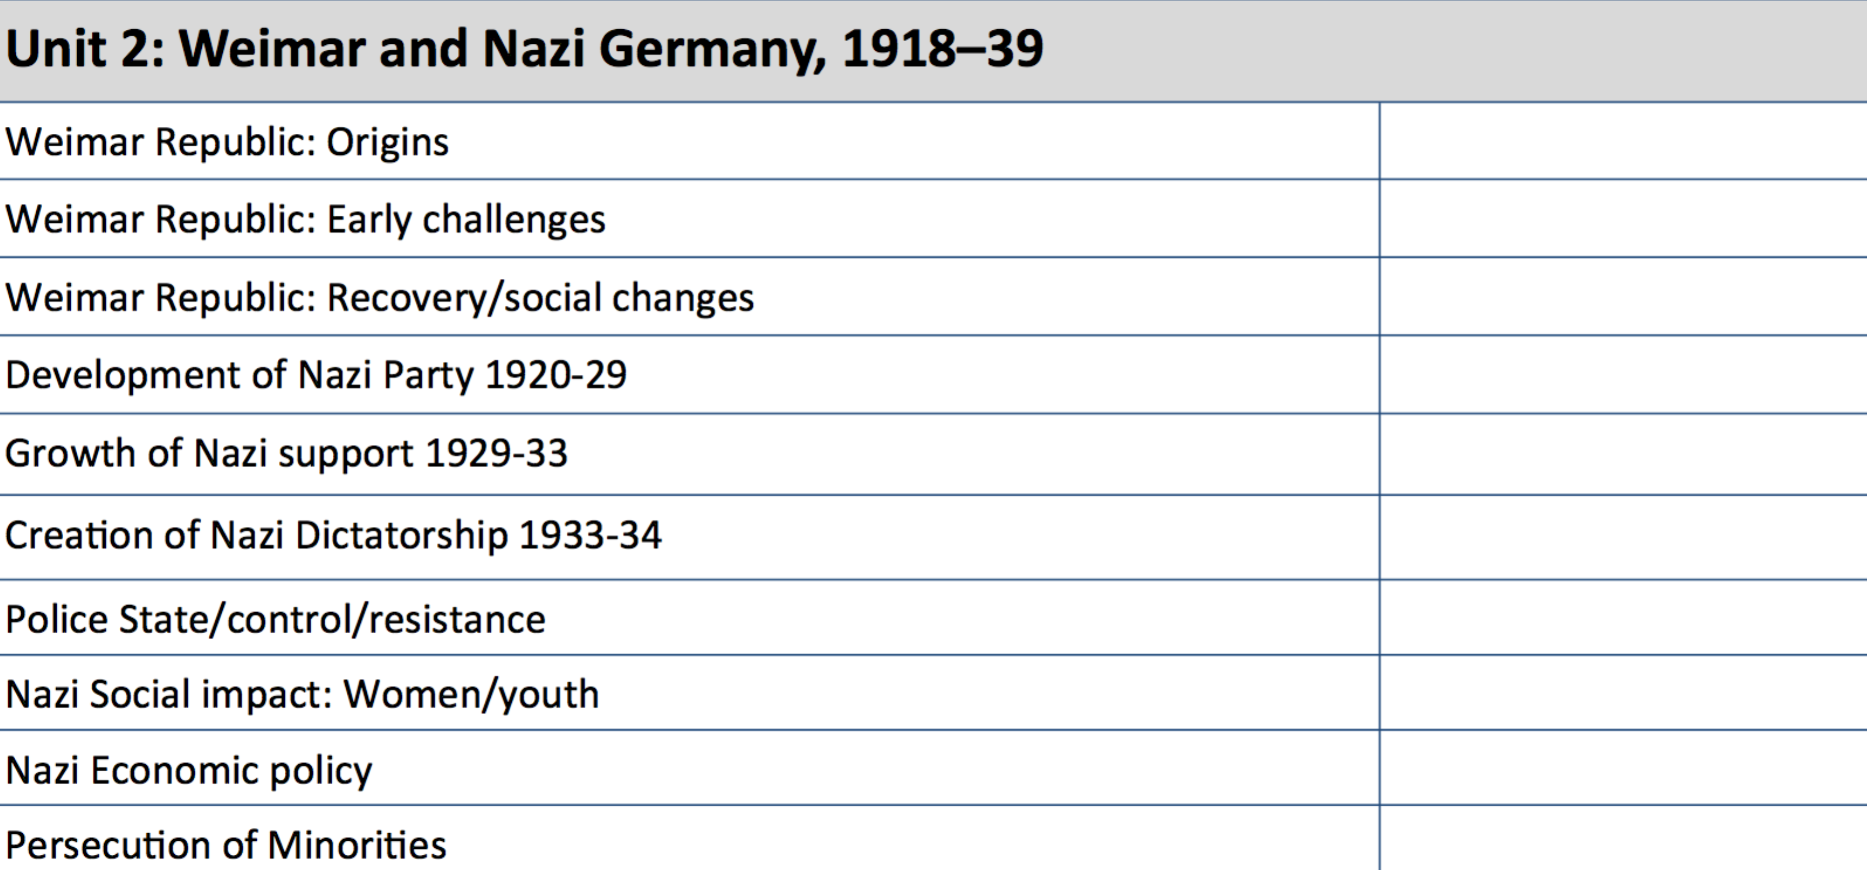

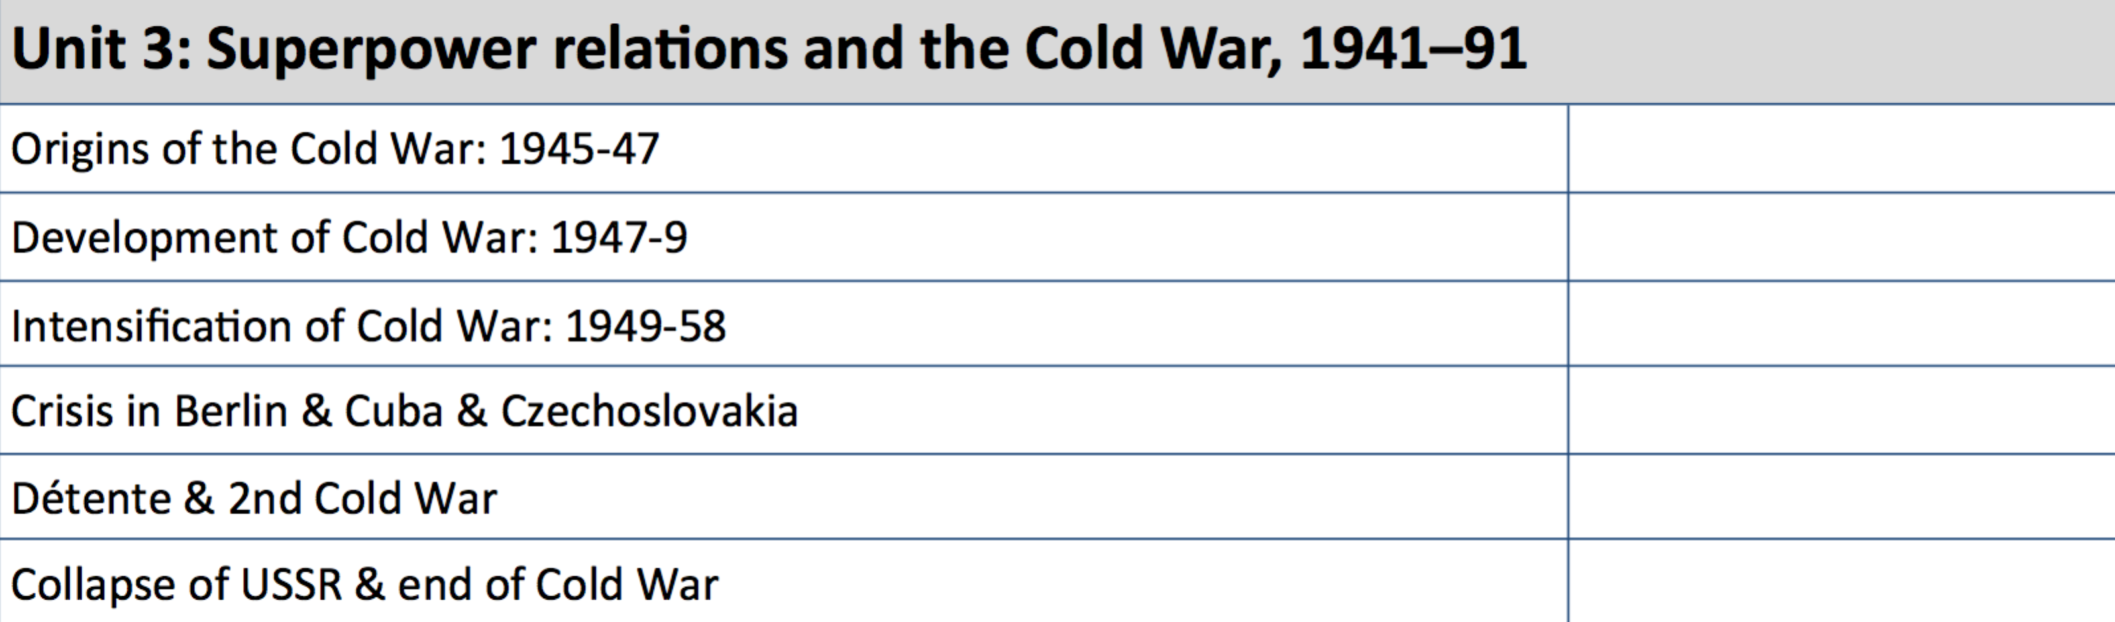

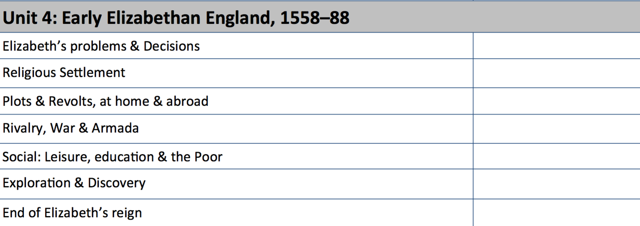
Support the school will provide
- Examination questions (past paper format)
- Topic list to see what must be covered

Exams
3 June am Paper 1: Thematic study and historic environment – 30% - 1 hour and 15 minutes
6 June pm Paper 2: Period study and British depth study (Cold War/ Elizabeth) – 40% - 1 hour and 45 minutes
11 June pm Paper 3: Modern depth study (Germany) – 30% - 1 hour and 20 minutes

Music
Exam Board
Pearson
https://qualifications.pearson.com/en/qualifications/edexcel-gcses/music-2016.html
https://qualifications.pearson.com/content/dam/pdf/GCSE/Music/2016/specification/Specification_GCSE_L1-L2_in_Music.pdf
Past Papers or Specimen papers and mark schemes
http://www.aqa.org.uk/subjects/geography/gcse/geography-8035/assessment-resources
How does the overall grade break down?
Component 1: Performing – 30% - Non-examined assessment
Component 2: Composing – 30% - Non-examined assessment
Component 3: Appraising – 40% - 1 hour and 45 minute examination

Guidance for Revision
- Using a revision guide or topic list (given by your teacher) to cover all the areas in each of the examinations so that you know what you need to cover.
- Making notes on each area to remind you of the skills involved.
- Practising exam questions again and again and again to make sure you know the skills inside out and back to front and can use them in different questions.

Component 3
Section A: Areas of study, dictation, and unfamiliar pieces
- Six questions related to six of the eight set works
- Short answers 1-4 marks per question
- Some multiple choice
- Key features of the set works
- Key terms
- How elements (Instrumentation, Structure, Tonality, Harmony, Rhythm, Texture) are used
- Context – how typical of this style/ period of music
- One short melody/rhythm completion exercise: Complete a short musical phrase either by adding the rhythm or pitch of notes
- One question on an unfamiliar piece
- musical elements
- musical contexts
- musical language
- Key signatures
- Musical techniques (astinato, melodic sequences, pedal points, tremolo)
- Cadences (perfect, plagal, imperfect, interrupted)
Section B: Extended response comparison between a set work and one unfamiliar piece
- compare and/or evaluate the musical elements, musical contexts and musical language of one set work with one unfamiliar piece of music
- As section A but compare & contrast elements, techniques & context
- Evidence from both scores
- Effects on listener
- Revise by listening to unheard pieces and picking key features

Support the school will provide
- Examination questions (past paper format)
- Topic list to see what must be covered

Exams
4 June pm Component 3: Appraising – 40% - 1 hour and 45 minute examination

PE
Exam Board
Pearson
https://qualifications.pearson.com/en/qualifications/edexcel-gcses/physical-education-2016.html
https://qualifications.pearson.com/en/qualifications/edexcel-gcses/physical-education-2016.html
Past Papers or Specimen papers and mark schemes
https://qualifications.pearson.com/en/qualifications/edexcel-gcses/physical-education-2016.coursematerials.html#filterQuery=category:Pearson-UK:Category%2FSpecification-and-sample-assessments
How does the overall grade break down?
Unit 1: Fitness and Body Systems – 36% 1 hour 45 mins examination
Unit 2: Health and performance - 24% - 1 hour 15 mins examination
Unit 3: Practical performance - 30% - Non-examined assessment
Unit 4: Personal Exercise Programme – 10% - Non-examined assessment

Guidance for Revision
- Using a revision guide or topic list (given by your teacher) to cover all the areas in each of the examinations so that you know what you need to cover.
- Making notes on each area to remind you of the skills involved.
- Practising exam questions again and again and again to make sure you know the skills inside out and back to front and can use them in different questions.

Unit 1: Fitness and Body Systems
Applied anatomy and physiology
- The structure and functions of the musculo-
- skeletal system
- The structure and functions of the cardio- respiratory system
- Anaerobic and aerobic exercise
- The short- and long- term effects of exercise
Movement analysis
- Lever systems, examples of their use in activity and the mechanical advantage they provide in movement
- Planes and axes of movement
Physical training
- The relationship between health and fitness and the role that exercise plays in both
- The components of fitness, benefits for sport and how fitness is measured and improved
- The principles of training and their application to personal exercise/ training programmes
- The long-term effects of exercise
- How to optimise training and prevent injury
- Effective use of warm up and cool down
Use of data

Unit 2: Health and Performance
Health, fitness and wellbeing
- Physical, emotional and social health, fitness and well-being
- The consequences of a sedentary lifestyle
- Energy use, diet, nutrition and hydration
Sport psychology
- Classification of skills (basic/ complex, open/closed)
- The use of goal setting and SMART targets to improve and/or optimise performance
- Guidance and feedback on performance
- Mental preparation for performance
Socio-cultural influences
- Engagement patterns of different social groups in physical activity and sport
- Commercial- isation of physical activity and sport
- Ethical and socio-cultural issues in physical activity and sport
Use of data

Support the school will provide
- Examination questions (past paper format)
- Topic list to see what must be covered

Exams
15 May am Unit 1: Fitness and Body Systems – 36% 1 hour 45 mins examination
17 May pm Unit 2: Health and performance - 24% - 1 hour 15 mins examination

RE Short Course
Exam Board
AQA
http://www.aqa.org.uk/subjects/religious-studies/gcse/religious-studies-short-course-8061
http://filestore.aqa.org.uk/resources/rs/specifications/AQA-8061-SP-2016.PDF
Past Papers and Specimen papers
http://www.aqa.org.uk/subjects/religious-studies/gcse/religious-studies-short-course-8061/assessment-resources
How does the overall grade break down?
Written paper – 100% - 1 hour 45 mins examination

Guidance for Revision
- Using a revision guide or topic list (given by your teacher) to cover all the areas in each of the examinations so that you know what you need to cover.
- Making notes on each area to remind you of the skills involved.
- Practising exam questions again and again and again to make sure you know the skills inside out and back to front and can use them in different questions.
- Reading over key terms and their definitions; testing peers on these
- Looking at key quotes noted down and explaining what topics could be connected to them and why

Section A: The study of religions: beliefs and teachings of two religions

Christianity: Beliefs and teachings
- Nature of God
- Omnipotent, just, loving, problem of evil, suffering
- Oneness of God and the Trinity
- Father, Son and Holy Spirit
- Creation
- Creationism, Intelligent Design, Theistic Evolution, role of Word & Spirit
- Incarnation and Jesus, Son of God
- Jesus as the Word of God
- Crucifixion
- Significance of the death of Jesus
- Resurrection, Ascension
- Life after death, judgement, heaven and hell
- Sin and salvation
- Original sin, law, grace and Spirit
- Role of Christ in salvation
- Forgiveness, atonement, reconciliation

Judaism: Beliefs and teachings
- Nature of God: God as One
- The Shema
- Nature of God: God as the creator
Creation from nothing
- Nature of God: God as lawgiver and judge; divine presence
- Loving and merciful God, Shekhinah
- Life after death, judgement and resurrection
- Different ideas within Judaism (e.g. Orthodox, Reform, Liberal)
- Nature and role of the Messiah
- Promised Land and covenant with Abraham
- Covenant at Sinai (with Moses) and 10 Commandments
- Key moral principles in Judaism
- Sanctity of life – Pikuach Nefesh
- Free will and mitzvot

Section B: Thematic studies: religious, philosophical and ethical studies
Theme 1: Relationships and families
- Christian, Jewish and other teachings about:
- Human sexuality
- Age of consent, heterosexuality and homosexuality
- Sexual relationships before and outside marriage
- Cohabitation, adultery, same sex marriage
- Contraception and family planning
- Forms of artificial contraception, natural contraception
- Divorce and remarriage
- Commitment, responsibility, faithfulness, reasons for divorce, impact of divorce, religious ideas about remarriage
- Nature of families in the 21st century
- Role of parents and children, extended and nuclear family, polygamy, same sex parents
- Purpose of families in the 21st century
- Procreation, stability and the protection of children, educating children in a faith.
- Attitudes to gender equality
- Gender equality, prejudice and discrimination examples
Theme 2: Religion, peace and conflict
- Violent protest and terrorism
- Reasons for war
- Nuclear war and weapons of mass destruction
- The just war
- Holy war
- Pacifism and peacemaking
- Religious responses to victims of war

Support the school will provide
- Examination questions (past paper format)
- Topic list to see what must be covered
- Revision sessions during the study leave block.
- Revision guides provided by teachers
Exams
20th May am Written paper – 100% - 1 hour 45 mins examination

GCSE RE Full Course
Exam Board
AQA
https://www.aqa.org.uk/subjects/religious-studies/gcse/religious-studies-a-8062
http://filestore.aqa.org.uk/resources/rs/specifications/AQA-8062-SP-2016.PDF
Past Papers and Specimen papers
https://www.aqa.org.uk/subjects/religious-studies/gcse/religious-studies-a-8062/assessment-resources
How does the overall grade break down?
Written papers – 100% - 2 x 1 hour 45 mins examinations

Guidance for Revision
- Using a revision guide or topic list (given by your teacher) to cover all the areas in each of the examinations so that you know what you need to cover.
- Making notes on each area to remind you of the skills involved.
- Practising exam questions again and again and again to make sure you know the skills inside out and back to front and can use them in different questions.
- Reading over key terms and their definitions; testing peers on these
- Looking at key quotes noted down and explaining what topics could be connected to them and why

Section A: The study of religions: beliefs and teachings of two religions

Christianity: Beliefs and teachings
- Nature of God
- Omnipotent, just, loving, problem of evil, suffering
- Oneness of God and the Trinity
- Father, Son and Holy Spirit
- Creation
- Creationism, Intelligent Design, Theistic Evolution, role of Word & Spirit
- Incarnation and Jesus, Son of God
- Jesus as the Word of God
- Crucifixion
- Significance of the death of Jesus
- Resurrection, Ascension
- Life after death, judgement, heaven and hell
- Sin and salvation
- Original sin, law, grace and Spirit
- Role of Christ in salvation
- Forgiveness, atonement, reconciliation

Christianity: Practices
- Worship – liturgical, non-liturgical, informal, private
- Prayer
- The sacraments: Baptism
- The sacraments: Holy Communion
- Celebrating Holy Communion
- Pilgrimage
- Celebrating festivals – Easter & Christmas
- The role of the church in the local community – food banks, street pastors
- The place of mission and evangelism
- Church growth
- Importance of the worldwide church
- Christian persecution
- Church responses to world poverty

Judaism: Beliefs and teachings
- Nature of God: God as One
- The Shema
- Nature of God: God as the creator
Creation from nothing
- Nature of God: God as lawgiver and judge; divine presence
- Loving and merciful God, Shekhinah
- Life after death, judgement and resurrection
- Different ideas within Judaism (e.g. Orthodox, Reform, Liberal)
- Nature and role of the Messiah
- Promised Land and covenant with Abraham
- Covenant at Sinai (with Moses) and 10 Commandments
- Key moral principles in Judaism
- Sanctity of life – Pikuach Nefesh
- Free will and mitzvot

Judaism: Practices
- The importance of the synagogue
- Interior features of a synagogue
- Worship in Orthodox and Reform synagogues
- Daily services and prayer
- Shabbat in the synagogue
- Shabbat in the home
- Worship in the home
- The written and oral law
- Ceremonies associated with birth
- Bar and Bat Mitzvah
- Marriage
- Mourning the dead
- Dietary laws
- Rosh Hashanah and Yom Kippur
- Pesach

Section B: Thematic studies: religious, philosophical and ethical studies

Theme A: Relationships and families
- Christian, Jewish and other teachings about:
- Human sexuality
- Age of consent, heterosexuality and homosexuality
- Sexual relationships before and outside marriage
- Cohabitation, adultery, same sex marriage
- Contraception and family planning
- Forms of artificial contraception, natural contraception
- Divorce and remarriage
- Commitment, responsibility, faithfulness, reasons for divorce, impact of divorce, religious ideas about remarriage
- Nature of families in the 21st century
- Role of parents and children, extended and nuclear family, polygamy, same sex parents
- Purpose of families in the 21st century
- Procreation, stability and the protection of children, educating children in a faith.
- Attitudes to gender equality
- Gender equality, prejudice and discrimination examples

Theme D: Religion, peace and conflict
- Violent protest and terrorism
- Reasons for war
- Nuclear war and weapons of mass destruction
- The just war
- Holy war
- Pacifism and peace-making
- Religious responses to victims of war

Theme E: Religion, Crime & Punishment
- Differences between sins and crimes
- Origins of evil
- Reasons for crime e.g. mental health, poverty
- Religious attitudes to lawbreakers and different types of crime
- Three aims of punishment – deterrence, reformation, retribution
- Religious attitudes to suffering and causing suffering to others
- Religious attitudes to the treatment of criminals – prison, corporal punishment and community service
- Religious attitudes to forgiveness
- Religious attitudes to the death penalty (e.g. sanctity of life)

Theme F: Religion, Human Rights & Social Justice
- Human rights
- Social justice
- Religious freedom
- Prejudice and discrimination - disability, race, gender
- Wealth – attitudes towards it
- Poverty and exploitation
- Giving money to the poor
Support the school will provide
- Examination questions (past paper format)
- Topic list to see what must be covered
- Revision sessions during the study leave block.
- Revision guides provided by teachers
Exams
13th May (pm) Written paper – 100% - 1 hour 45 mins examination
20th May (am) Written paper – 100% - 1 hour 45 mins examination

Visual Communication: Level 2 Technical Award
Exam Board
AQA
http://filestore.aqa.org.uk/subjects/AQA-4550-W-SP-14.PDF
Past Papers
https://www.aqa.org.uk/exams-administration/exams-guidance/find-past-papers-and-mark-schemes
How does the overall grade break down?
Unit 1: Skills Demonstration (30%)
Unit 2: Extended Making Project (30%)
Unit 3: Written Exam: I hour 30 mins (40%)

Grading: Credit, Advanced Credit, Pass, Merit, Distinction, Distinction*
Guidance for Revision
- Use topic list (given by your teacher) to cover all the areas in each of the examinations so that you know what you need to cover.
- Make notes on each area to remind you of the skills involved.
- Practise exam questions again and again to make sure you know the skills inside out and back to front and can use them in different questions.
Include each type of question:
- Multiple choice
- Short answer
- Notes and sketches
- Extended response

Unit 3: Written Exam.
Learners will be assessed on their knowledge and understanding of the following:
- planning
- visual communication techniques
- processes in industry
- health and safety
- materials and stock forms
- tools and equipment
- social and environmental issues
- business organisation and activity and intellectual property in visual communication companies
- career opportunities

Support the school will provide
- Examination questions (past paper format)
- Topic list to see what must be covered

Exam

